# **File menu** (getting data in and out of iNZight)

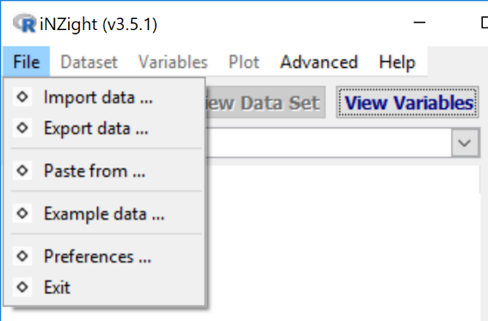

The **File menu** provides 4 ways of getting data into iNZight.

* ***Importing a*** ***file on your compute***r (use *Import data …*)
* ***Importing*** a data set ***from an*** ***internet url*** (use *Import data …*)
* ***Copying and pasting***data from programs like from Excel or Google sheets (use *Paste from …*)
* Using ***Example data*** sets stored within iNZight (use *Example data …*)

The **File** menu also allows for ***saving/exporting data*** that you have modified in some way in iNZight (use *Export data …*)

## File menu (details)

The File menu enables getting data into and out of iNZight   
(**Exception**: *Preference*s changes program behaviour)

* **Import data …** (*from computer file or interne*t)
* **Export data …** (*useful if have modified the dataset*)

* **Paste from …** (*pasting copied data*)
* **Example data ...** (*use an example dataset*)
* **Preferences …** (***change program behaviour***)
* **Exit** (*quit iNZight*)

### Import data …

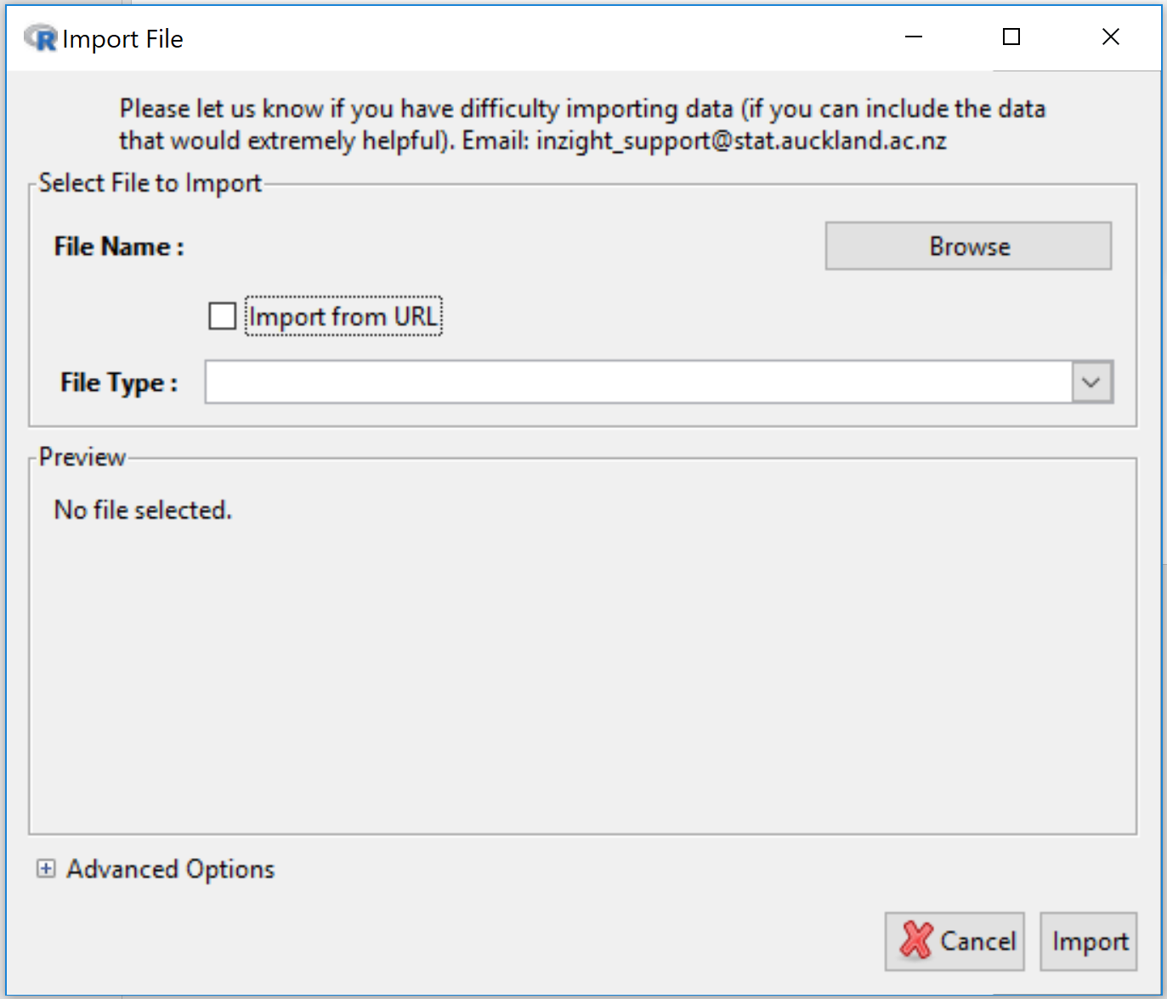

***By default*** imports ***from a file*** on your computer. Throws up a **browser** button to initiate a dialogue for navigating to the file you want.

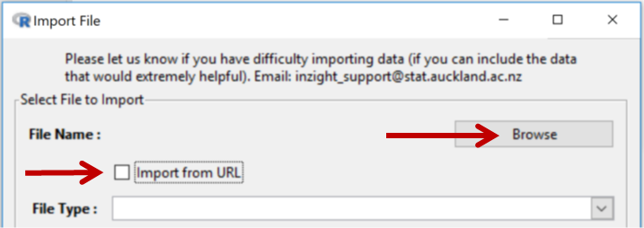

On clicking the **Import from url** checkbox the behaviour changes (as below)

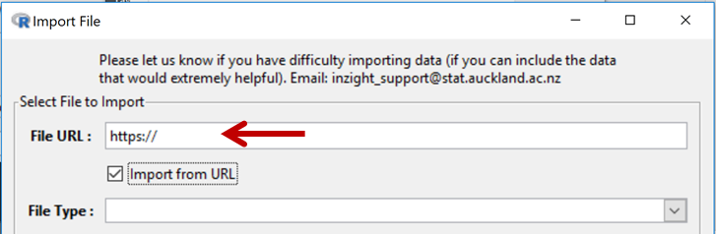

Type or paste in the url address of the file you want to import  
(*when pasting a full url, ensure the prepopulated “https:// ” is overwritten*)

#### File Types:

NZight **assumes** that data sets are in **rows = cases** by **columns = variables format**

iNZight can import files of the following types:

* Comma Separated Values text files (.csv)
* Tab-delimited Text files (.txt)
* 97-2003 Excel files (.xls)
* 2007 Excel files (.xlsx)
* SPSS files (.sav)
* SAS Data files (.sas7bdat)
* SAS Xport files (.xpt)
* STATA fles (.dta)
* R Object files (.rds)
* RDAta files (.RData, .rda)

**By default**, iNZight identifies the type of the file being imported by looking for one of these filename extensions. iNZight attempts to read the file and populate the **Preview** panel. If no preview appears iNZight has been unable to read the file.

Click the **Import** button (at bottom right) when you are happy with what appears in the Preview panel.

The **Advanced Options** at the bottom left the dialog box (Click on the “**+**” to expand) allows you to change default behaviour.

### Export data …

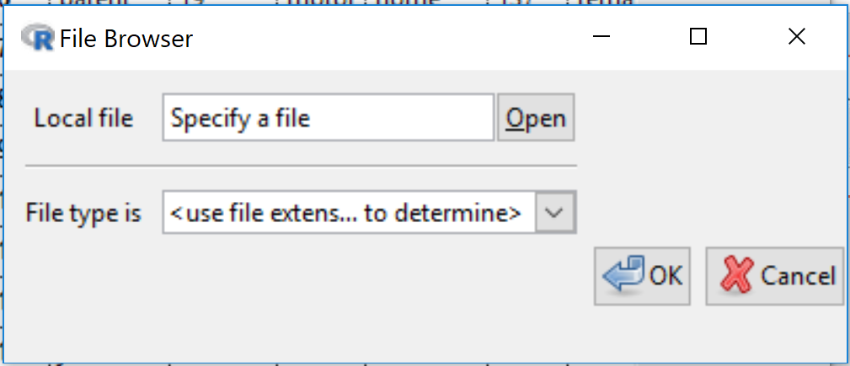

**Clicking “Open”** initiates the following dialog

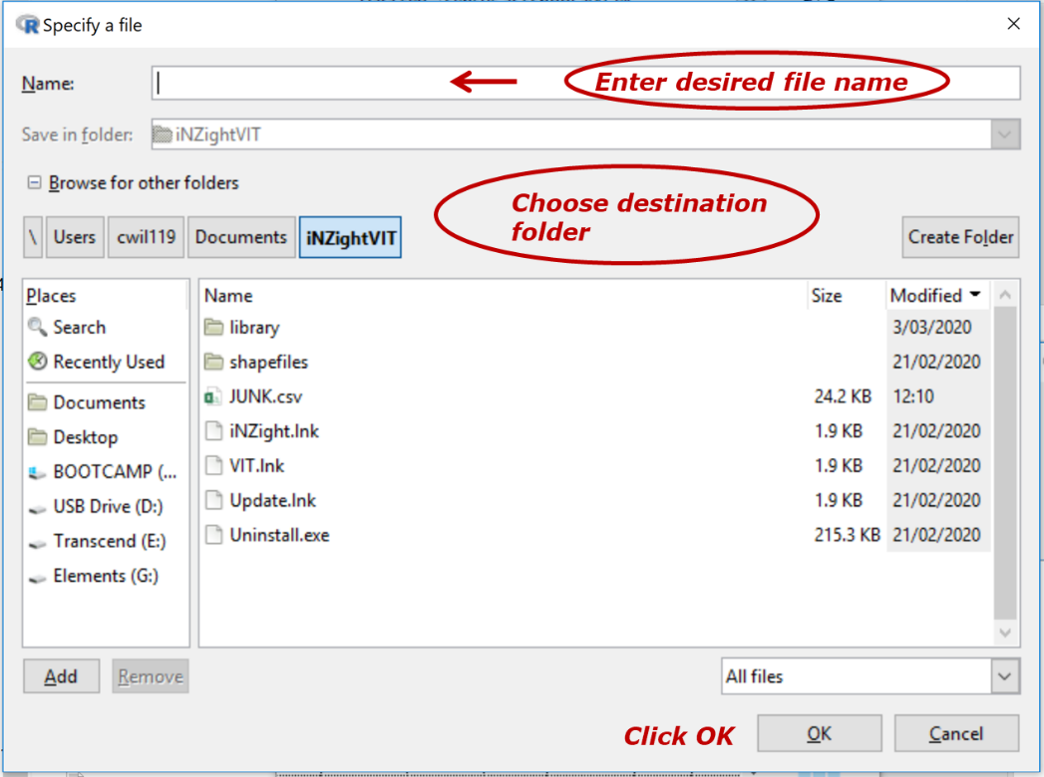

This brings you back to …



**Choose** from allowable file extensions and **click OK**

(If you have already put the correct extension on your filename you can click OK without choosing an file type extension)

### Paste from …

This enables copying and pasting data from sources like *Excel* files or *Google sheets*

Click **Load** when finished

### Example data ...

Enables the loading of data files stored inside iNZight.  
*First select* a **Module** and *then* a **Dataset** stored with that Module.

### Preferences …

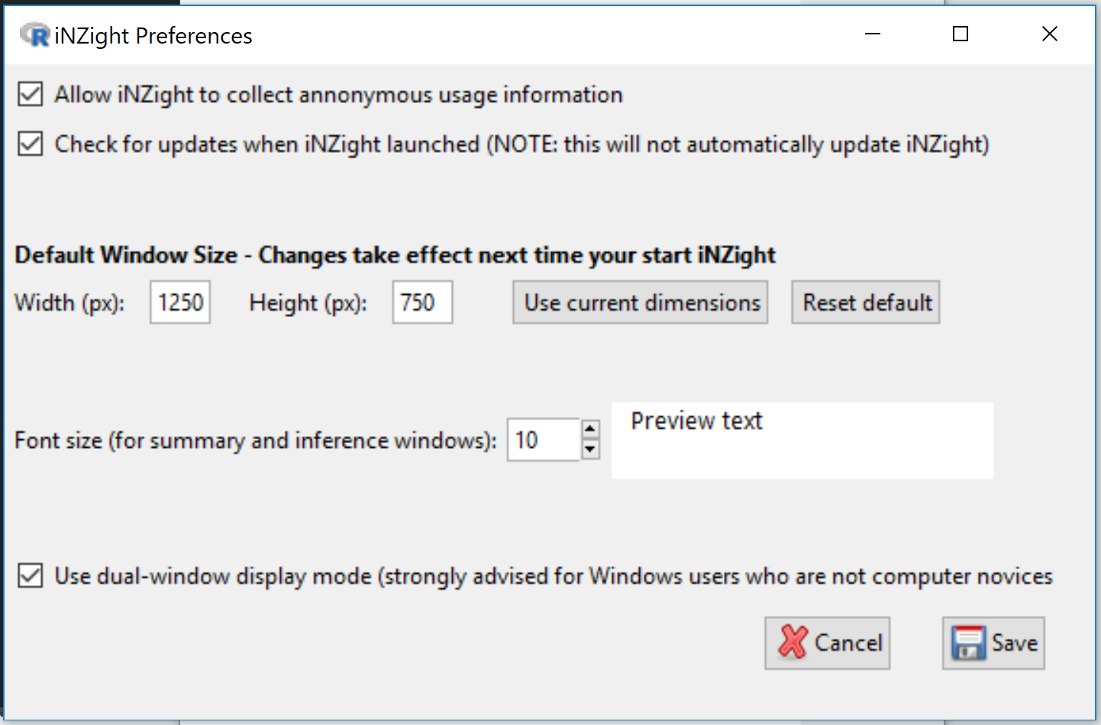

**Preferences** enables changing some of the behaviours of iNZight such as default window and font sizes.

***Preference changes do not take effect***until the next time you start up iNZIght.

**Single window versus Dual-window display**

While *single-window* is the default, *dual-window* mode is better for all Windows users except computer novices

